Contribution of Gestalt School- 1

Gestalt Principles of Perceptual Organization
Wertheimer presented the principles of perceptual organization. He asserted that we perceive objects in the same way we perceive apparent motion, as unified wholes rather than clusters of individual sensations. These Gestalt principles are essentially rules by which we organize our perceptual world.
One underlying premise is that perceptual organization occurs instantly whenever we sense various shapes or patterns. The discrete parts of the perceptual field connect, uniting to form structures distinct from their background. Perceptual organization is spontaneous and inevitable whenever we look or listen. Typically, we do not have to learn to form patterns, as the associationists claimed, although some higher-level perception, such as labeling objects by name, does depend on learning.
According to Gestalt theory, the brain is a dynamic system in which all elements active at a given time interact. The visual area of the brain does not respond separately to individual elements of visual input, connecting these elements by some mechanical process of association. Rather, the elements that are similar or close together tend to combine, and elements that are dissimilar or farther apart tend not to combine.
Several perceptual organization principles are listed as follows and are illustrated in Figure.
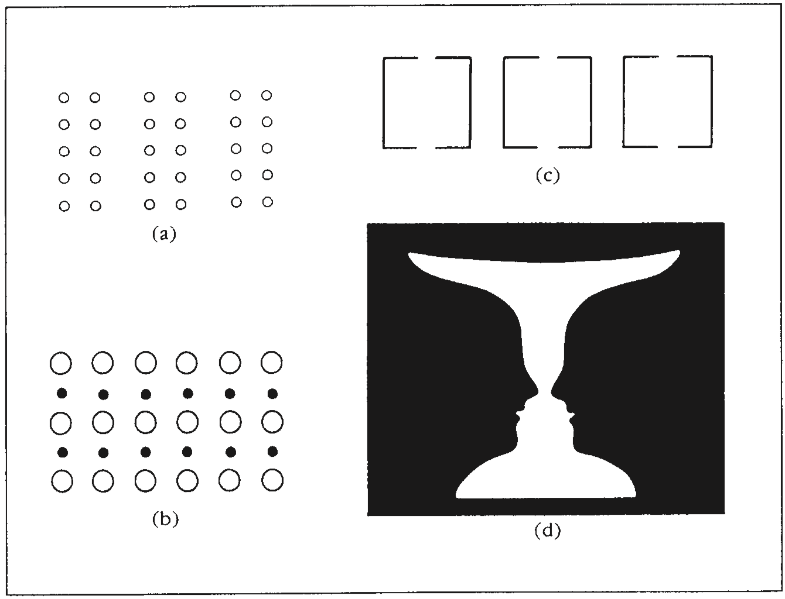
Examples of perceptual organization.

1. Proximity. Parts that are close together in time or space appear to belong together and tend to be perceived together. In Figure (a), you see the circles in three double columns rather than as one large collection.
2. Continuity. There is a tendency in our perception to follow a direction, to connect the elements in a way that makes them seem continuous or flowing in a particular direction. In Figure (a), you tend to follow the columns of small circles from top to bottom.
3. Similarity. Similar parts tend to be seen together as forming a group. In Figure (b), the circles and the dots each appear to belong together, and you tend to perceive rows of circles and rows of dots instead of columns.
4. Closure. There is a tendency in our perception to complete incomplete figures, to fill in gaps. In Figure (c), you perceive three squares even though the figures are incomplete.
5. Simplicity. We tend to see a figure as being as good as possible under the stimulus conditions; the Gestalt psychologists called this prägnanz, or good form. A good Gestalt is symmetrical, simple, and stable and cannot be made simpler or more orderly. The squares in Figure (c) are good Gestalts because they are clearly perceived as complete and organized.
6. Figure/ground. We tend to organize perceptions into the object being looked at (the figure) and the background against which it appears (the ground). The figure seems to be more substantial and to stand out from its background. In Figure (d), the figure and the ground are reversible; you may see two faces or you may see a vase, depending on how your perception is organized.
These organizing principles do not depend on higher mental processes or past experiences but are present in the stimuli themselves. Wertheimer called them peripheral factors, but he also recognized that central factors within the organism influence perception. For example, the higher mental processes of familiarity and attitude can affect perception. In general, however, the Gestalt psychologists focused more on the peripheral factors of perceptual organization than on the effects of learning or experience.

